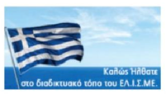

΅Welcome to the HEL.I.S.S. website

www.elisme.gr / elisme@elisme.gr
88 Patision Avenue - 1st floor, Athens 10430
Tel. +30 210 8211025

The Hellenic Institute for Strategic Studies (HEL.I.S.S) is an independent, non-profit institute for strategic studies, research, and analysis based in Athens, Greece. It is a natural sequel to the Greek Institute for Strategic Studies, which was founded in 1994.
The Institute was created by retired officials of the Armed Forces and then its range extended to include figures from other fields, such as academics, diplomats, entrepreneurs, economics and members of security forces.
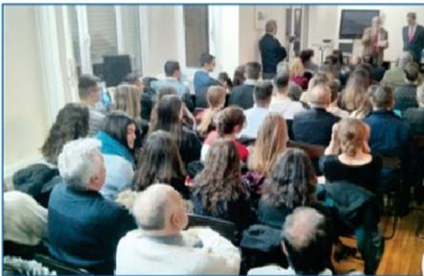
Objectives: The non-aligned and reliable expression of public discourse on geopolitical issues (geo-strategy, geo-economics), on foreign and domestic affairs of national interest and international affairs, with particular regard to issues of European interest, in line with the advisory contribution to the fulfilment of the relevant national interest objectives, and European integration.
Members: HEL.I.S.S. is composed of its members, who are natural persons and their number is unlimited. They are adult Greek citizens, regardless of gender, who are able to exercise their political rights and satisfy the requirements provided for by the Statute of HEL.I.S.S.
Structure: The structure and operation of HEL.I.S.S. are based on the Statute and on the Regulations for Operation and Organization. The Institute is managed by a 12-member Board of Directors. The successful operation of the Institute shall be supported by ad-hoc groups and committees.
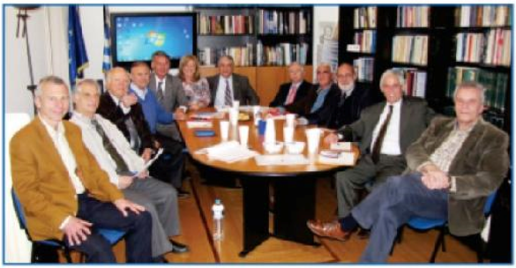
Income: The income of HEL.I.S.S comes from the annual membership fees and gifts from its members and others, from any grants of the public and private sectors and any kind of revenue arising from the exploitation of its assets, as well as coming from its own activities (eg. studies, seminars, research, international programs, etc.)
Actions: In order to achieve its objectives HEL.I.S.S. develops a series of actions, like the ones mentioned below:
- Conferences, Lectures, Workshops, Book presentations: Seminars, Lectures, Workshops, and Book presentations are some of the important and successful actions of HEL.I.S.S. functioned either independently by the institute or in co-operation with relevant institutions and service providers.
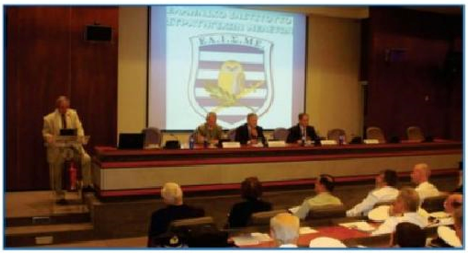
- Seminars: HEL.I.S.S. organises seminars through which reputable speakers provide the ability to students, professional unions and individuals with special interests to attend remotely or in a class.
- Participations & Co-operations: Participations in international fora, TV and radio programs. Co-operations with government agencies, with the academic society and with relevant institutions of the private sector.
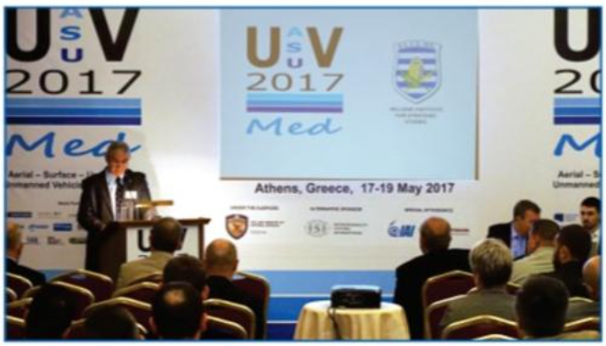
- Studies: Studies on issues of special interest relating to the purpose of the institute. The studies are either commissioned by public or private bodies or carried out within the interest of HEL.I.S.S.
- Research: Research is conducted by members or collaborating individuals and bodies and is accordingly promoted.
- Website: The website is a variety of informative material, articles, and files on international, European and international affairs.
- Publications: The institute publishes the quarterly magazine “Reflections” as well as research publications series on issues of national interest, with the participation of appropriate members of the institute or with contribution from external partners.
- Internships: Our institute offers internships to a small number of students of Greek universities, whose studies are relevant to HEL.I.S.S.’ activities.
- Library: The institute offers a rich lending library to its members.
The Hellenic Institute for Strategic Studies offers valuable insight to society through the voluntary and consistent contribution of its members, who aspire towards continuous exploitation of HEL.I.S.S. by the national decision making centers, and also towards steady and systematic information of the public opinion over all the range of national interest topics.
